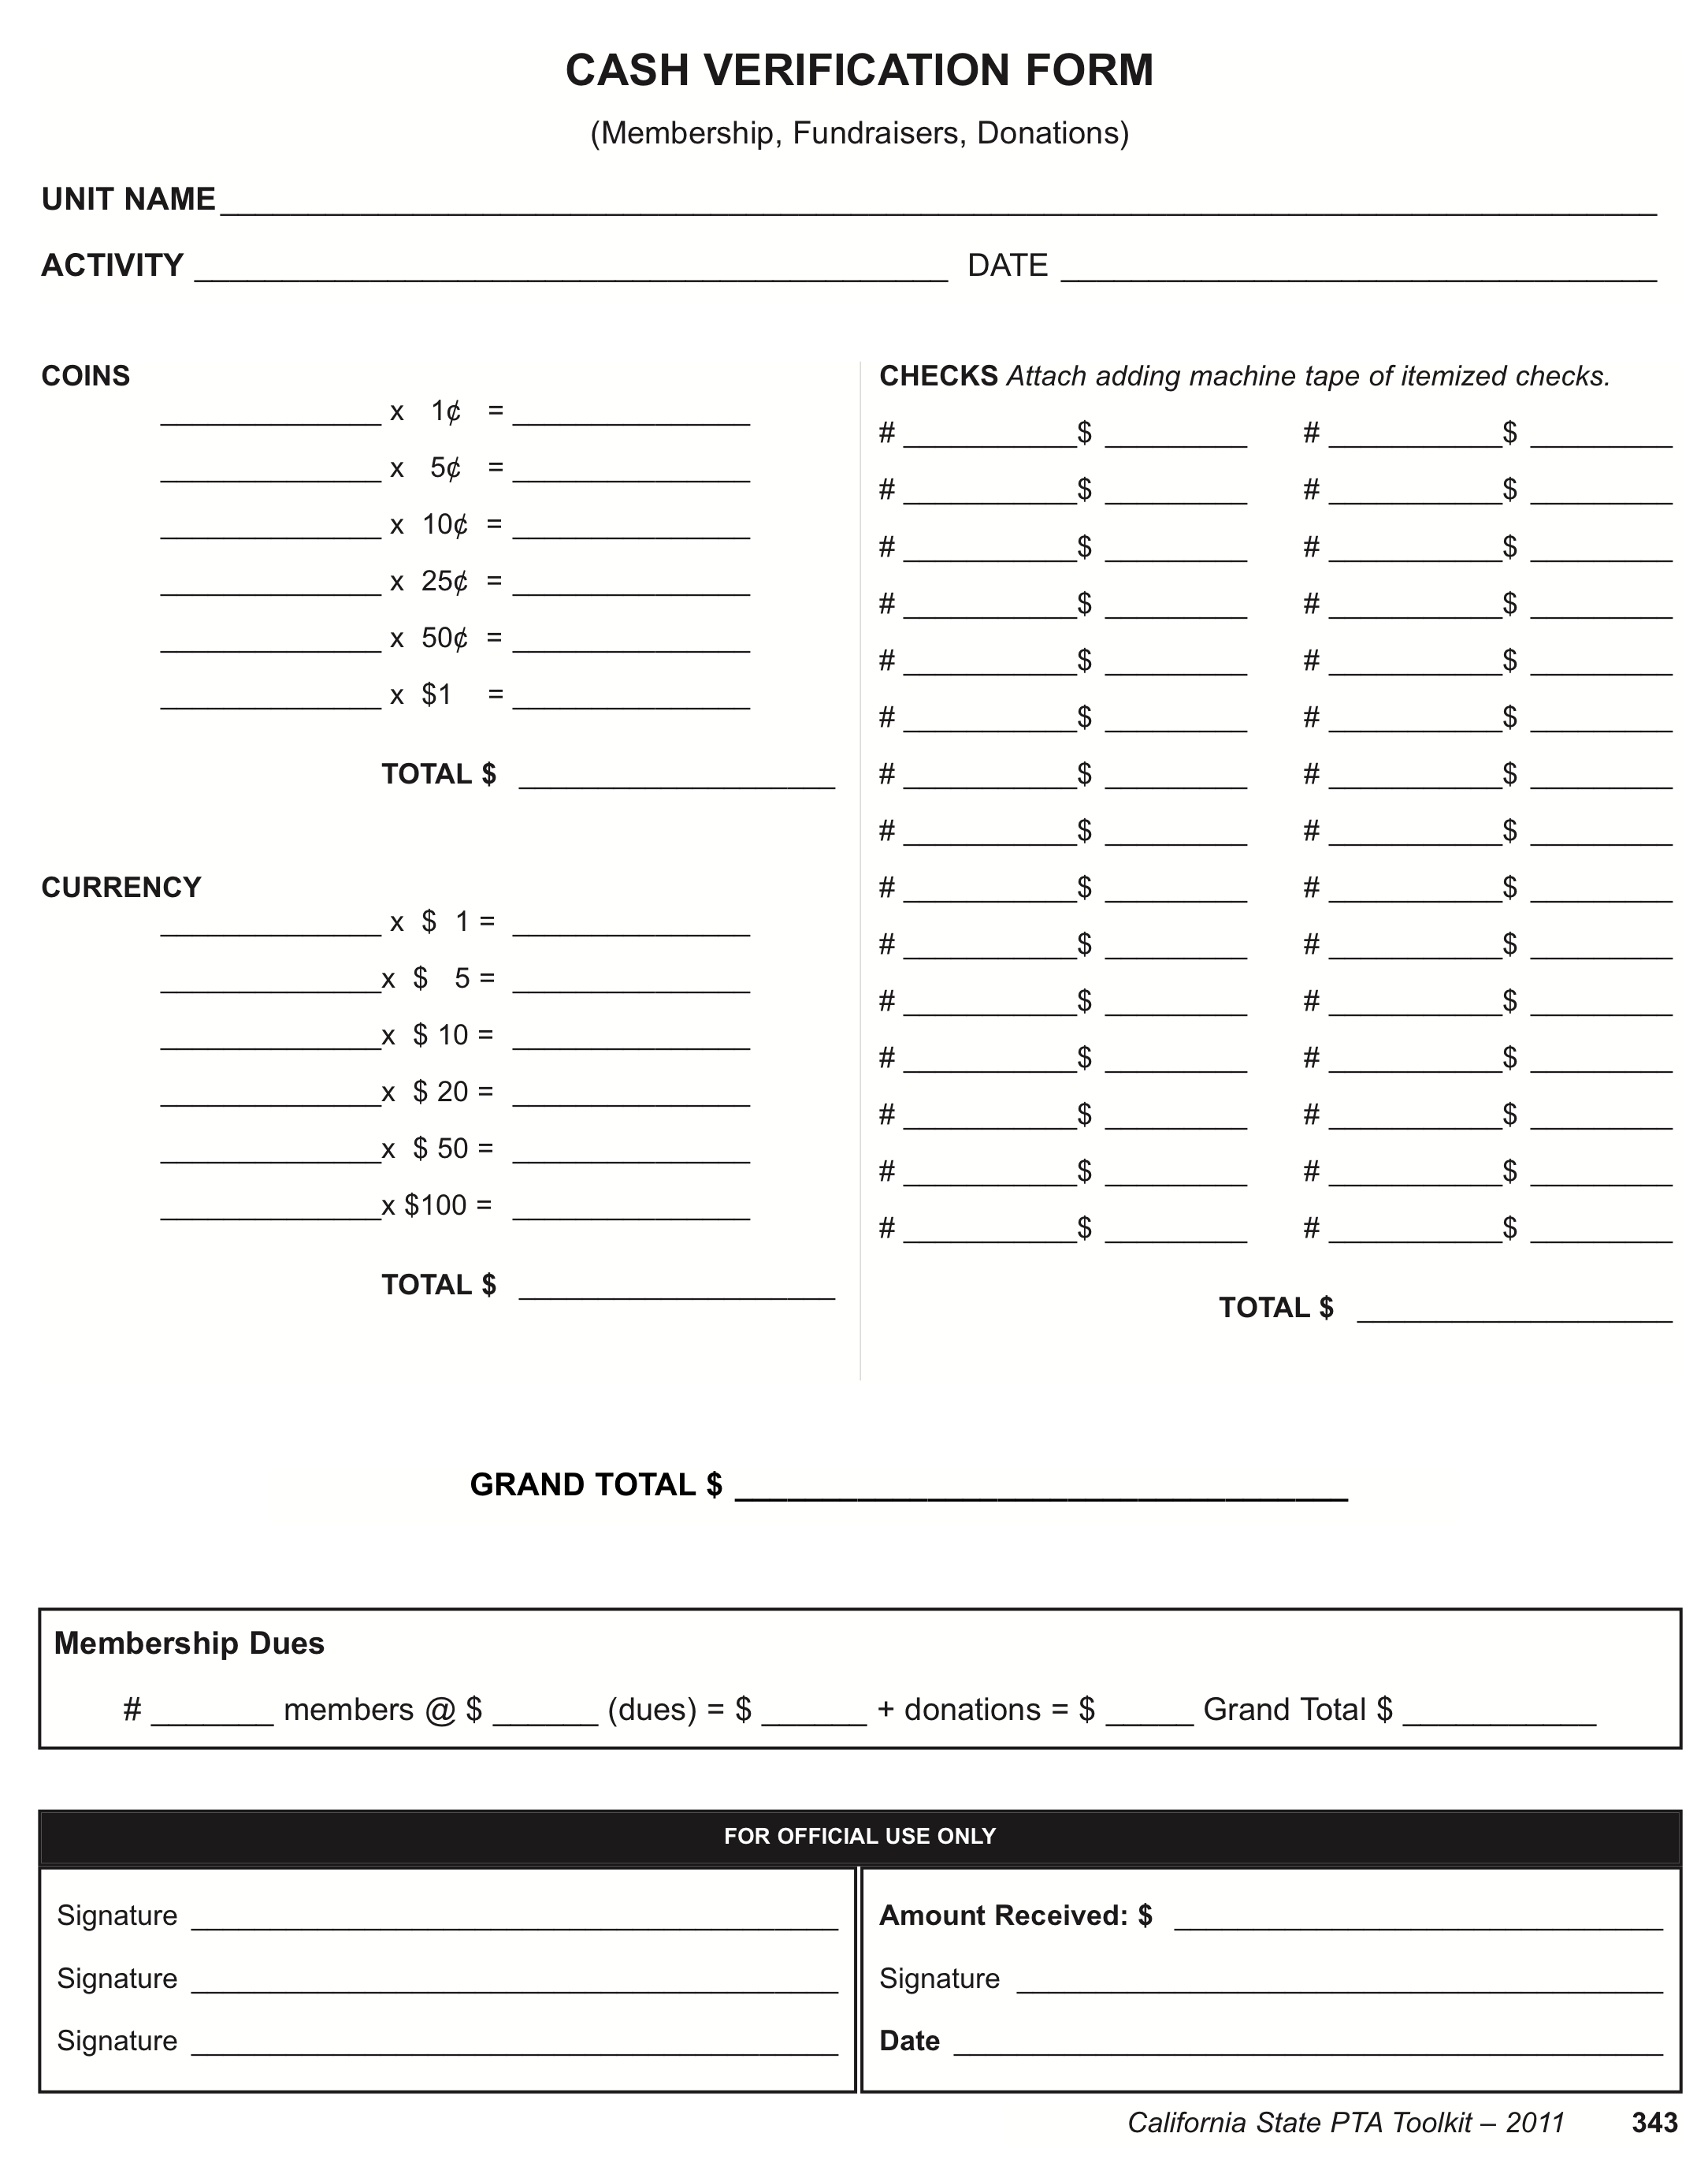

Instructions for Using the Cash Verification Form:

This form is used to document receipt of coins, currency, and checks from PTA events and programs. This includes membership, fundraisers, and donations.

This form helps to safeguard volunteers’ handling of PTA funds.

There should be two people counting/receiving the cash. One person should be a PTA Board member.

Both counters will verify the amount of cash received, fill out the form, and sign the form. Checks can also be listed on the form.

Make a copy of the form and leave a copy along with the cash and/or bundle of checks, in the locked PTA drop box. Keep the other copy for your own records in case of discrepancies. The PTA drop box is located in the PTA Nook.

Use one form per day. Keep track of all the forms. Each individual program or event should have a master copy of all cash and checks received. The master list is given to the Financial Secretary.

Whenever there is cash or checks in the box in the office, please send an email to the Financial Secretary (financialsecretary@cherrychasepta.org) and Treasurer (treasurer@cherrychasepta.org) to alert them of the money.

